1.Write a program to find whether a no. is even or not.

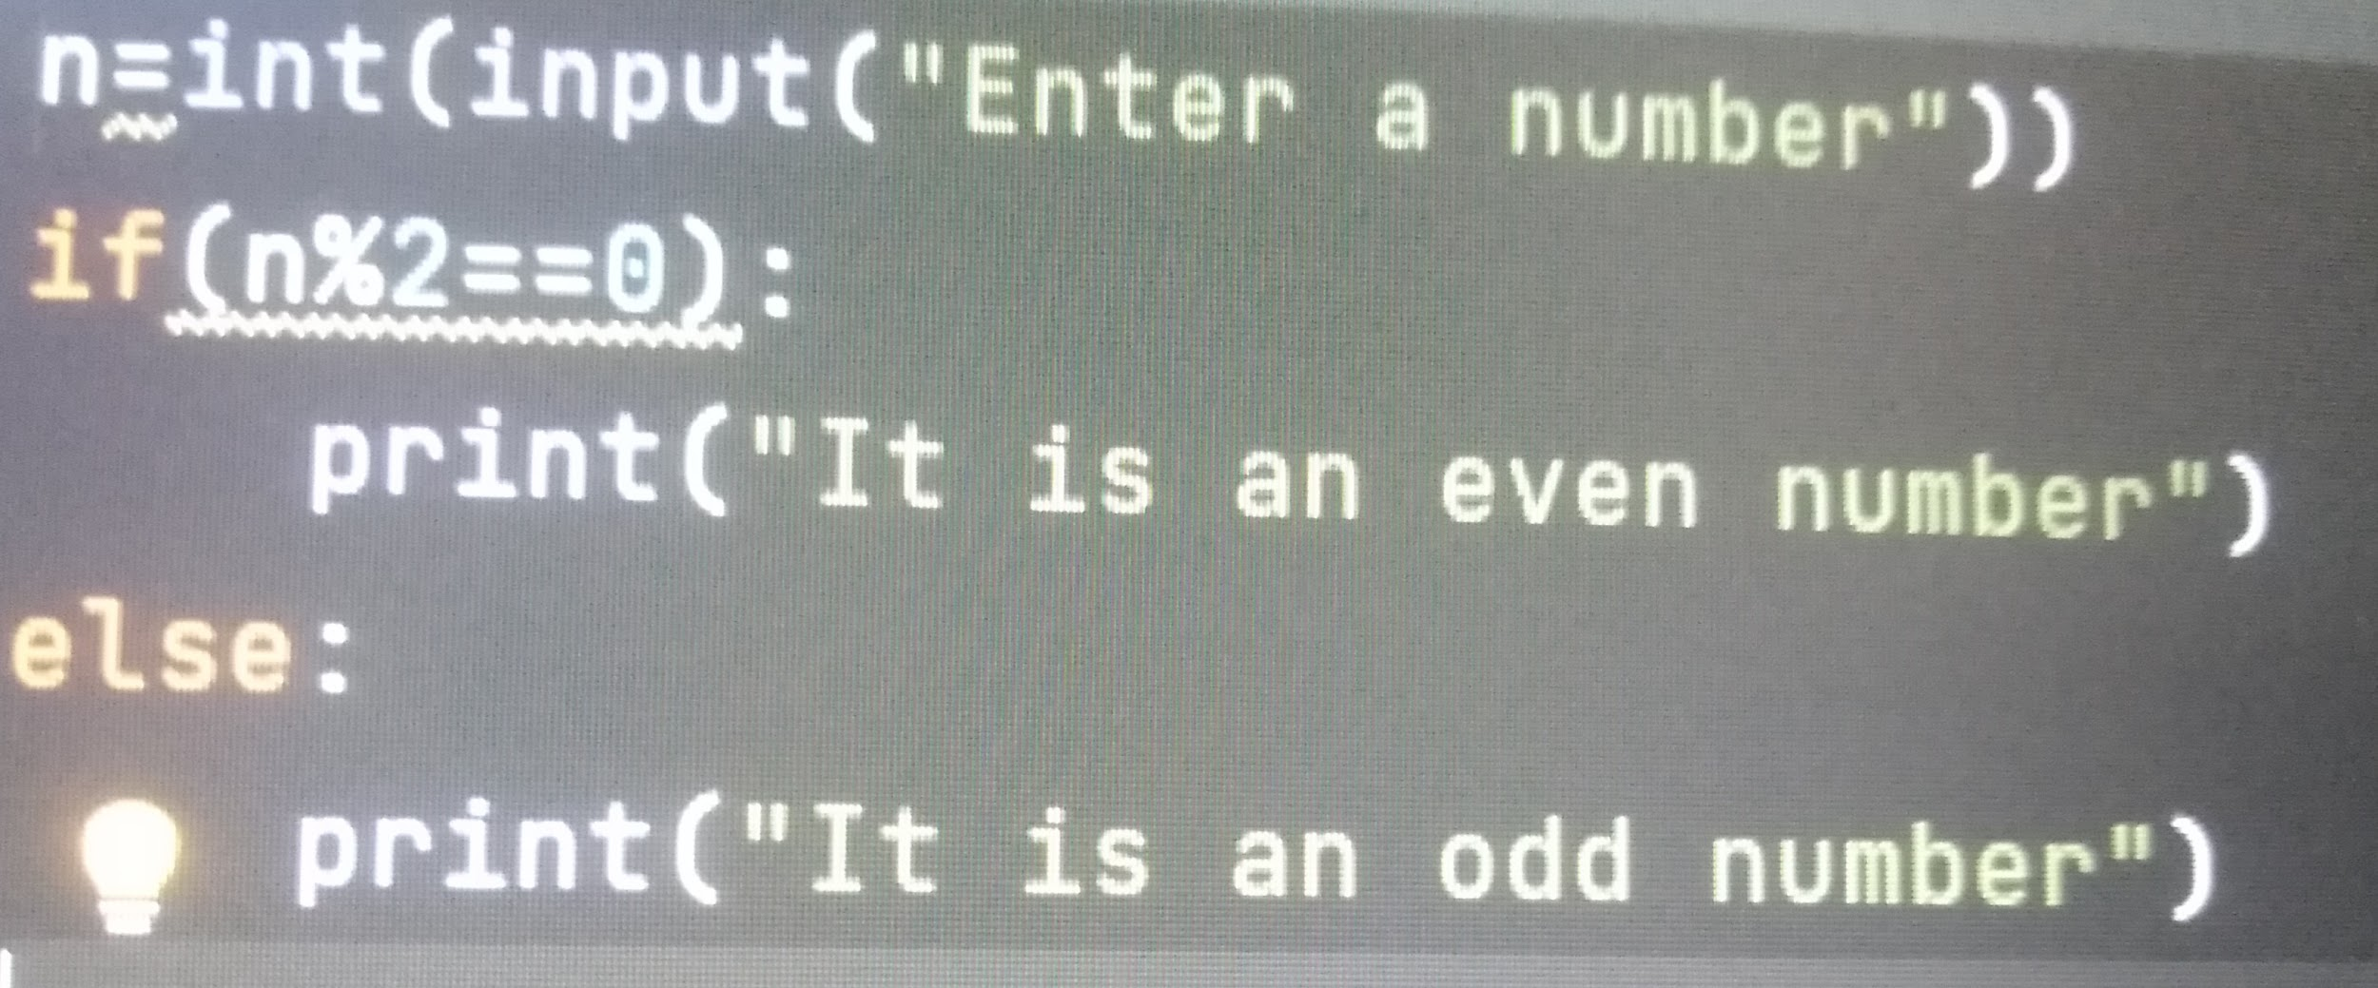

2.Write a program to implement do while using while loop.

